Census Income Prediction
Problem Statement, Data Understanding and ML Flow

Introduction:
Machine learning allows us to use data to make predictions and understand patterns in the real world. In many cases, we work with datasets that contain information about people, products, or events, and our goal is to build a model that can learn from this data and make accurate predictions on new examples. In this assignment, we use a well-known dataset from the U.S. Census to explore how different personal and work-related factors relate to a person’s income level. By applying a simple machine learning workflow—such as cleaning the data, analyzing it, training models, and evaluating their performance—we can build a system that predicts whether someone earns more than $50K per year. This assignment helps build practical skills in handling real-world data and applying core ML concepts.

Problem Statement:
- The goal of this project is to predict whether an individual earns more than $50,000 per year using demographic and employment-related attributes from the 1994 U.S. Census dataset.
- This is a binary classification problem with two possible outcomes: <=50K and >50K. The dataset contains a mix of continuous and categorical variables such as age, education, occupation, marital status, and hours worked per week.
- The objective is to build a machine learning model that accurately classifies income level based on these features.

Understanding the Data & Variables:
Dataset Overview:
- Source: 1994 U.S. Census Database (extracted by Barry Becker)
- Total Instances: 48,842 records
- Features: 14 attributes (6 continuous, 8 categorical)
- Target Variable: Income (Binary classification: ≤$50K or >$50K)
- Dataset Type: Multivariate, Classification Task
- The dataset was split into: Training set: 2/3 of the data (32561 records)
Test set: 1/3 of the data (16282 records)

Data Extraction Criteria:
The dataset was extracted using the following conditions:
- Age > 16 years
- Adjusted Gross Income (AGI) > $100
- Final weight (AFNLWGT) > 1
- Hours per week > 0
Target Variable:
- income: >50K or <=50K

Variable Descriptions:

Variable Name | Role | Type | Demographic | Description | Units | Missing Values
age | Feature | Integer | Age | N/A |  | no
workclass | Feature | Categorical | Income | Private, Self-emp-not-inc, Self-emp-inc, Federal-gov, Local-gov, State-gov, Without-pay, Never-worked. |  | yes
fnlwgt | Feature | Integer |  |  |  | no
education | Feature | Categorical | Education Level | Bachelors, Some-college, 11th, HS-grad, Prof-school, Assoc-acdm, Assoc-voc, 9th, 7th-8th, 12th, Masters, 1st-4th, 10th, Doctorate, 5th-6th, Preschool. |  | no
education-num | Feature | Integer | Education Level |  |  | no
marital-status | Feature | Categorical | Other | Married-civ-spouse, Divorced, Never-married, Separated, Widowed, Married-spouse-absent, Married-AF-spouse. |  | no
occupation | Feature | Categorical | Other | Tech-support, Craft-repair, Other-service, Sales, Exec-managerial, Prof-specialty, Handlers-cleaners, Machine-op-inspct, Adm-clerical, Farming-fishing, Transport-moving, Priv-house-serv, Protective-serv, Armed-Forces. |  | yes
relationship | Feature | Categorical | Other | Wife, Own-child, Husband, Not-in-family, Other-relative, Unmarried. |  | no
race | Feature | Categorical | Race | White, Asian-Pac-Islander, Amer-Indian-Eskimo, Other, Black. |  | no
sex | Feature | Binary | Sex | Female, Male. |  | no
capital-gain | Feature | Integer |  |  |  | no
capital-loss | Feature | Integer |  |  |  | no
hours-per-week | Feature | Integer |  |  |  | no
native-country | Feature | Categorical | Other | United-States, Cambodia, England, Puerto-Rico, Canada, Germany, Outlying-US(Guam-USVI-etc), India, Japan, Greece, South, China, Cuba, Iran, Honduras, Philippines, Italy, Poland, Jamaica, Vietnam, Mexico, Portugal, Ireland, France, Dominican-Republic, Laos, Ecuador, Taiwan, Haiti, Columbia, Hungary, Guatemala, Nicaragua, Scotland, Thailand, Yugoslavia, El-Salvador, Trinadad&Tobago, Peru, Hong, Holand-Netherlands. |  | Yes
income | Target | Binary | Income | >50K, <=50K. |  | No

Machine Learning Flow (High-Level Pipeline):
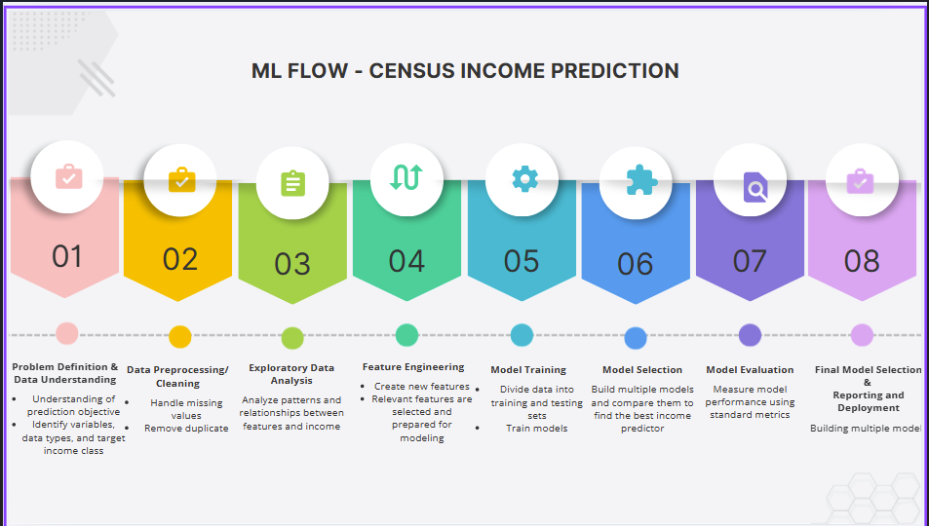

- Problem Definition and Data Understanding:
The project aims to develop a classification model that predicts whether a person earns more than $50,000 annually using demographic and employment-related census features. The dataset is explored to understand variable types, target classes, and initial patterns that may influence income levels.

- Data Preprocessing/Cleaning:
The dataset is prepared for analysis by handling missing values in categorical attributes such as workclass, occupation, and native-country. Data consistency is ensured by verifying correct data types and removing any invalid or duplicate records if present.

- Exploratory Data Analysis:
Exploratory analysis is performed to study the distribution of features and their relationship with income levels. Visualizations and summary statistics are used to identify patterns, trends, class imbalance, and potential influential factors affecting income classification.

- Feature Engineering:
Relevant features are selected and prepared for modeling. Redundant or highly correlated attributes are identified to reduce complexity, ensuring that the dataset is suitable for effective learning by machine learning models.

- Model Training (Train/Test):
Suitable machine learning classification models are trained using the prepared dataset. The objective of this step is to allow the models to learn patterns that distinguish individuals earning more than $50,000 from those earning less.

- Model Selection:
Model selection involves evaluating multiple algorithms—such as Logistic Regression, Decision Trees, Random Forests, and XGBoost—to identify which one delivers the highest accuracy and generalization for predicting income levels. Each model offers different strengths, so performance is compared using metrics like precision, recall, and overall predictive power.

- Model Evaluation:
The trained models are evaluated using standard classification performance measures to assess how well they predict income classes. Model behavior is analyzed to ensure reliable and consistent predictions.

- Final Model Selection (Prediction), Reporting and Deployment:
The best-performing model is selected based on strong, well-balanced evaluation metrics, making it dependable for predicting whether an individual earns more than $50K. The results are clearly reported through performance summaries and key insights, and the final model is prepared for deployment by integrating it into practical systems or applications.

Conclusion:
By systematically understanding the dataset and its variables, a clear problem statement was established for predicting income levels using machine learning. The outlined steps provide a structured and logical workflow that ensures proper data handling, feature selection, and model development. This approach forms a strong foundation for building accurate and reliable machine learning models on real-world census data.

